

**UNIVERSITY OF PETROLEUM & ENERGY STUDIES**

**SCHOOL OF COMPUTER SCIENCE**

***Department of Cybernetics***

**GRAPHICS AND ANIMATIONS TOOLS**

LAB FILE

SESSION(2020-21)

Course: BTech with specialization in Open Source & Open Standards

Submitted to: Submitted by:

Dr. Durgansh Sharma Kanish Rajpali

Associate Professor SAP: 500061910

Department of Cybernetics Roll no: R100217*032*

**Experiment 1:** Installation of GIMP and Blender

**GIMP Installation**

Step1: Installation of GIMP 2.10 will require downloading of the package from the official website of GIMP i.e. [www.gimp.org](http://www.gimp.org) (GNU Image Manipulation Program).

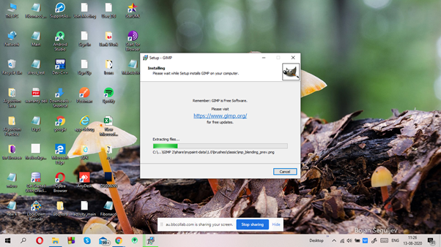

Step2: Installing GIMP using the setup wizard.

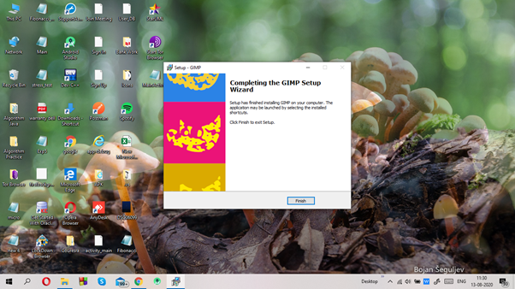

Step3: Loading of the user interface of GIMP.

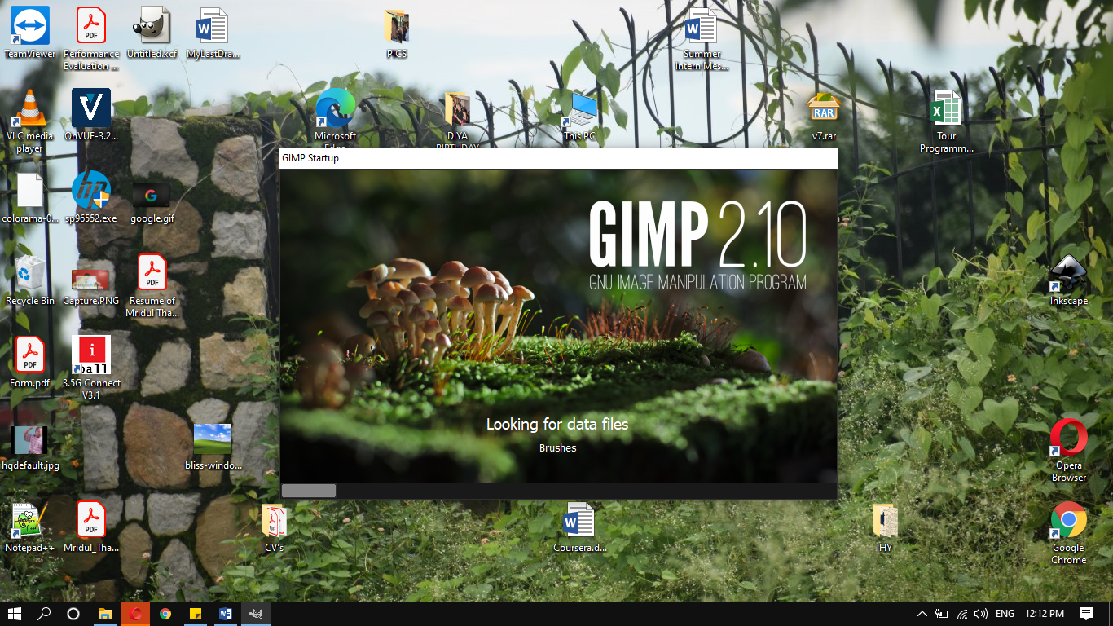

Step 4: The user interface of GIMP

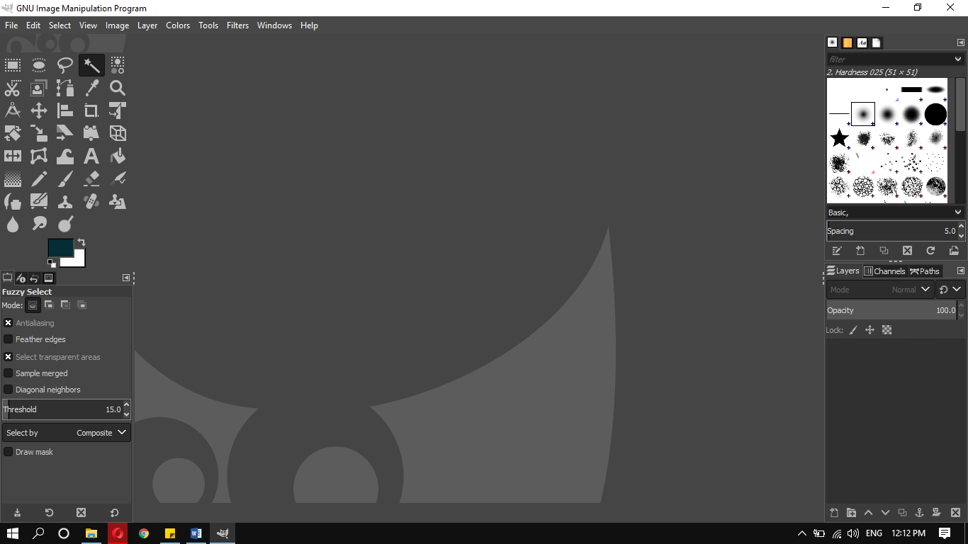

**Blender Installation**

Step1: Installation of Blender Package Installer downloaded from [www.blender.org/download](http://www.blender.org/download)

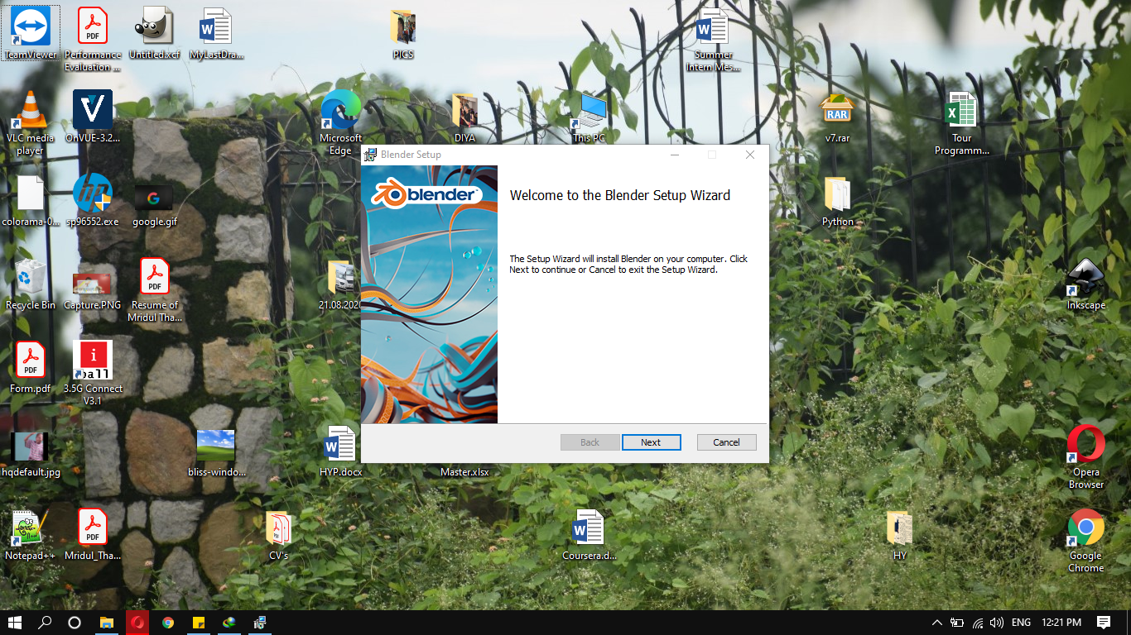

Step2: Accepting the user-agreement.

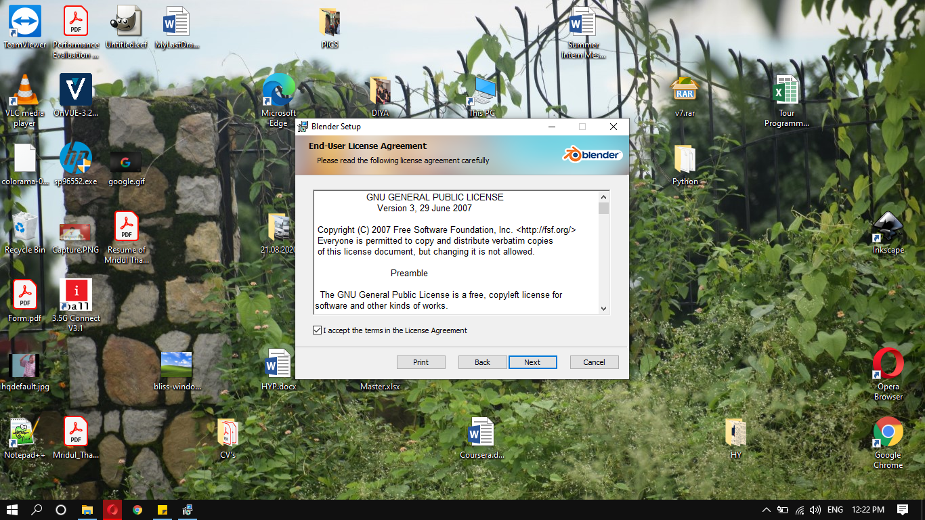

Step3: Installing Blender, set Custom path if you want to or leave it at default location.

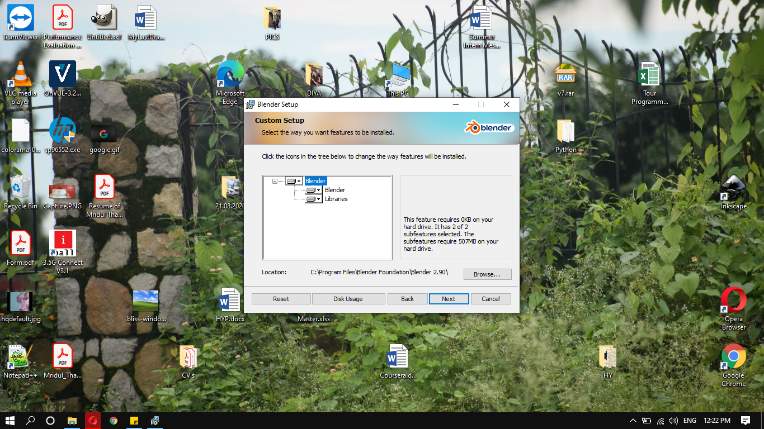

Step4: Completion of the setup.

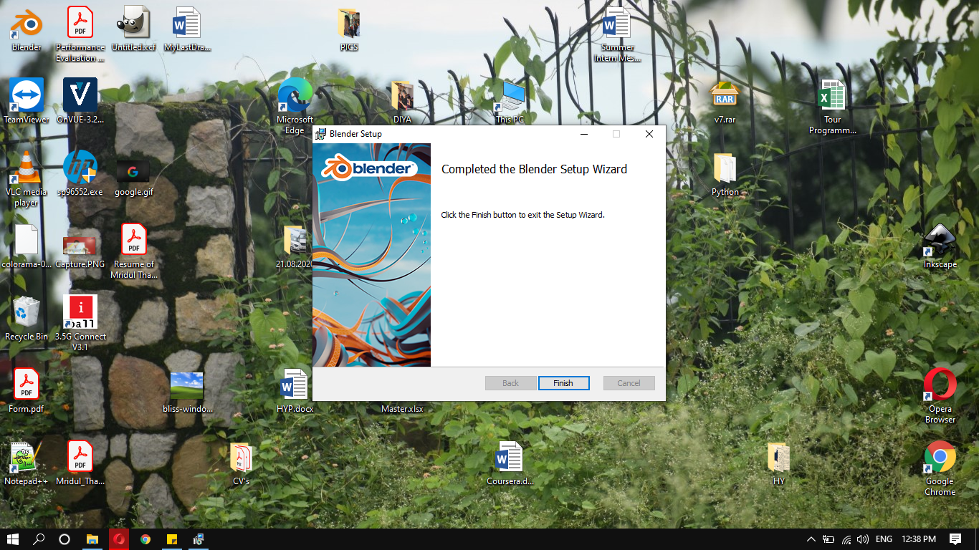

Step5: The user interface of Blender.

